**ASSIGNMENT**

Student name: DANG VIET ANH | HE151359

Student name: TRAN XUAN QUANG | HE153654

Student name: DOAN HAI PHONG | HE151364

Teacher: nguyen THI BICH THUY

DBI202 – DATABASE OF library MANAGEMENT SYSTEM

November 9, 2021

# TABLE OF CONTENTS

## INTRODUCE THE PROBLEM…………………………………………………………………………………………….

### Describe the problem……………………………………………………………………………………………………….

### Goals…………………………………………………………………………………………………………………………………..

## entity – relationship – er…………………………………………………………………………………………

### SET-UP ENTITY – RELATIONSHIP …………………………………………………………………………………………..

### difinITION entity – attributE ………………………………………………………………………………………….

## Database and ENTITY RELATIONSHIP DIAGRAM (ERD)………………………………………………..

### PUBLISHER……………………………………………………………………………………………………………………………

### KINDOFBOOK……………………………………………………………………………………………………………………….

### BOOKS….………………………………………………………………………………………………………………………………

### STAFFS…………………………………………………………………………………………………………………………………..

### READERS……………………………………………………………………………………………………………………………….

### BORROW……..……………………………………………………………………………………………………………………….

### BORROWBOOKS_DETAILS……..………………………………………………………………………………………………

### BOOKS_RETURN……..…………………………………………………………………………………………………………….

### COMPENSATION……..…………………………………………………………………………………………………………….

### DIAGRAM overview……..……………………………………………………………………………………………………

## SQL COMMAND

### QUERY USING ORDER BY………………………………………………………………………………………………………

### QUERY USING INNER JOIN……………………………………………………………………………………………………

### QUERY USING AGGREGATE FUNCTIONS…………………………………………………………………………………

### QUERY USING THE GROUP BY AND HAVING CLAUSES……………………………………………………………

### QUERY THAT USES A SUB-QUERY AS A RELATION………………………………………………………………….

### QUERY THAT USES PARTIAL MATCHING IN THE WHERE CLAUSE…………………………………………….

### STORE PROCEDURE……………………………………………………………………………………………………………….

### trigger……………………………………………………………………………………………………………………………….

# INTRODUCE THE PROBLEM

## Describe the problem

Nowaday, libraries were faced with an information explosion and the rapid growth rate of their collections. The issues confronting library administrators during that period were mainly physical managements involving shelving and weeding of materials, storage space, users’ in-house access to the collection, and preservation of the materials. After our team researched, the results are as follows:

* Each person who borrows books needs to have a separate account to manage information instead of checking the physical library account, that information includes necessary personal information such as phone number, address, gender, etc. count, date of birth...
* Each employee of the library also has a separate account to manage the borrowing of books from the library, and has more information of the same staff as the person who borrows the book..
* Books are categorized by publisher and book genre, one producer can produce many books and one genre can have many books.
* The book loan voucher will have a link between an employee and a borrower to represent each time a book is borrowed containing information about the date of borrowing.
* The details of the loan slip will store information about the loan slip, borrowed books, number of books borrowed and return date.

## goals

This database is written to solve the stages and procedures of the library by retrieving information on the computer without the need for manual work as before. This helps both library managers and readers easily control the information of books as well as the return of books in the library.

# entity – relationship – erD

## set-up entity – relationship

* Some symbols used in the model

**Attibute**

|  |  |
| --- | --- |
| * Key / identifier attribute |  |
| * Attribute description / description | **ENTITY**  Attribute |
| * Entity | **WEAK ENTIRY** |
| * Weak entity | *Relationship* |
| * Relationship |  |
| * Connectivity (force) = 1 |  |
| * Connectivity = N |  |

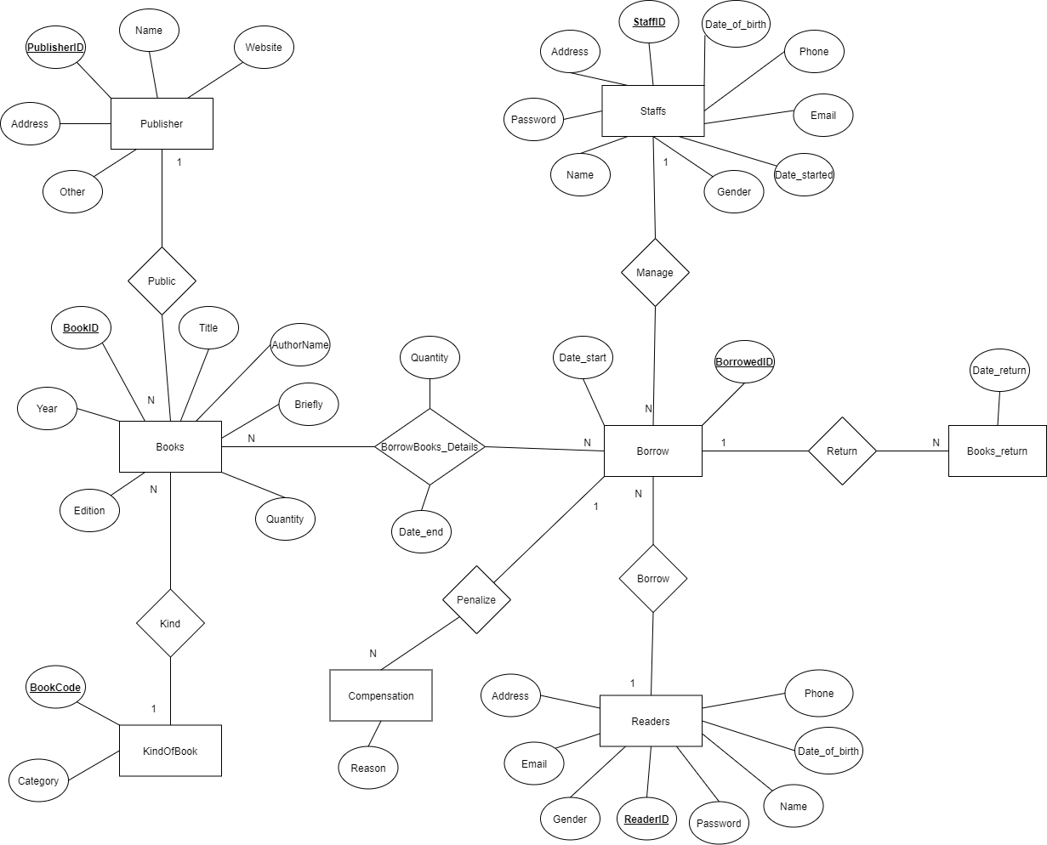

## difinITION entity – attributE

Base on the problem description and management objectives, we can present several entities and attributes of the entity as follow:

* **Publisher**: PublisherID, Name, Address, Website, Other.
* **KindOfBook:** BookCode, Category.
* **Books**: BookID, BookCode, PublisherID, Title, AuthorName, Year, Edition, Quantity, Brief.
* **Staffs**: StaffID, Password, Name, Date_of_birth, Address, Gender, Phone, Email, Date-started.
* **Readers**: ReaderID, Password, Name, Date_of_birth, Address, Gender, Email.
* **Borrow**: BorrowedID, StaffID, ReaderID, Date_start.
* **BorrowBooks_details**: BorrowID,BookID, Quantity, Date_end.
* **Books_return**: BorrowID,Date_return.
* **Compensation**: BorrowedID, Reason.

# database and entity diagram

Just for example on some tables (other table are similar, you have to define all the tables in your database). Note: to run the query you have to define the table 1 first then go to the side tables much

### cREATE DATABASE **LIBRARY_MANAGEMENT_SYSTEM**

--create database

CREATE DATABASE LIBRARY_MANAGEMENT_SYSTEM

### **Create table publisher**

***Entity - Attribute:***

***Code:***

--create table Pulisher

CREATE TABLE Publisher(

PublisherID char(50) NOT NULL PRIMARY KEY,

Name nvarchar(200) NOT NULL,

Address nvarchar(200) NOT NULL,

Website char(100),

Other nvarchar(200))

***Example:***

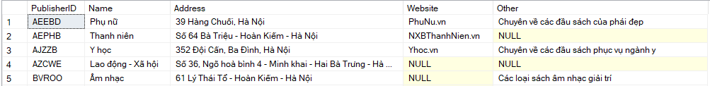

### **Create table kindofbook**

***Entity - Attribute:***

***Code:***

--create table KindOfBook

CREATE TABLE KindOfBook(

BookCode char(50) NOT NULL PRIMARY KEY,

Category nvarchar(200) NOT NULL)

***Example:***

### **Create table Books**

***Entity - Attribute:***

***Code:***

--create table Books

create table Books(

BookID char(50) NOT NULL PRIMARY KEY,

Title nvarchar(100) NOT NULL,

AuthorName nvarchar(100),

PublisherID char(50) NOT NULL,

BookCode char(50) NOT NULL,

Year int check (Year <= YEAR(getDate())),

Edition int,

Quantity int NOT NULL,

Briefly nvarchar(1000)

constraint fk_Books_KindOfBook FOREIGN KEY(BookCode) references KindOfBook(BookCode),

constraint fk_Books_Publisher FOREIGN KEY(PublisherID) references Publisher(PublisherID)

)

***Example:***

### Create TABLE **Staffs**

***Entity - Attribute:***

***Code:***

--create table Staffs

CREATE TABLE Staffs(

StaffID char(50) NOT NULL PRIMARY KEY CHECK (StaffID like 'FU[0-9][0-9][0-9][0-9][0-9][0-9]'),

Name nvarchar(100) NOT NULL,

Address nvarchar(200),

Date_of_birth date NOT NULL check (Date_of_birth < getDate()),

Gender bit NOT NULL check (Gender like 0 or Gender like 1),

Phone char(50) UNIQUE CHECK (Phone like '[0-9][0-9][0-9][0-9][0-9][0-9][0-9][0-9][0-9][0-9]'),

Email char(100),

Date_started date NOT NULL,

Password char(50) NOT NULL

)

***Example:***

### create table **readers**

***Entity - Attribute:***

***Code:***

--create table Readers

create table Readers(

ReaderID char(50) NOT NULL PRIMARY KEY CHECK (ReaderID like '[A-Z][A-Z][0-9][0-9][0-9][0-9][0-9][0-9]'),

Name nvarchar(100) NOT NULL,

Address nvarchar(200),

Date_of_birth date NOT NULL check (Date_of_birth < getDate()),

Email char(100),

Gender bit NOT NULL check (Gender like 0 or Gender like 1),

Password char(50) NOT NULL

)

***Example:***

### create table **Borrow**

***Entity - Attribute:***

***Code:***

--create table Borrow

create table Borrow(

BorrowID char(50) NOT NULL PRIMARY KEY,

StaffID char(50) NOT NULL,

ReaderID char(50) NOT NULL,

Date_start date NOT NULL,

constraint fk_Borrow_Readers FOREIGN KEY(ReaderID) references Readers(ReaderID),

constraint fk_Borrow_Staffs FOREIGN KEY(StaffID) references Staffs(StaffID))

***Example:***

### create table **Borrowbooks_details**

***Entity - Attribute:***

***Code:***

--create table BorrowBooks_details

CREATE TABLE BorrowBooks_details(

BorrowID char(50) NOT NULL,

BookID char(50) NOT NULL,

Quantity int NOT NULL,

Date_end date NOT NULL,

constraint fk_BorrowBooks_details_Borrow FOREIGN KEY(BorrowID) references Borrow(BorrowID),

constraint fk_BorrowBooks_details_Books FOREIGN KEY(BookID) references Books(BookID)

primary key(BorrowID,BookID)

)

***Example:***

### Create table **BOOKs_return**

***Entity - Attribute:***

***Code:***

--create table Books_return

CREATE TABLE Books_return(

BorrowID char(50) NOT NULL,

Date_return date NOT NULL,

constraint fk_Books_return_Borrow FOREIGN KEY(BorrowID) references Borrow(BorrowID))

***Example:***

### create table **Compensation**

***Entity - Attribute:***

***Code:***

--create table Compensation

create table Compensation(

BorrowID char(50) NOT NULL,

Reason nvarchar(200) NOT NULL,

constraint fk_PHAT_MUONSACH FOREIGN KEY(BorrowID) references Borrow(BorrowID))

***Example:***



# V. sql command

I using Microsoft SQL Server 2019, this server build intelligent, mission-critical applications using a scalable, hybrid database platform that has everything built in—from in-memory performance and advanced security to in-database analytics.

## query using order by

***Code:***

SELECT * FROM Staffs s

ORDER BY s.Name

***Result:***

We use query containing ORDER BY to sort the list ascending or descending by the values of a domain. SELECT * FROM Staffs command give us all record in Staffs table and then sort the records ascending by name

## query using inner join

***Code:***

SELECT * FROM Books b

inner join Publisher p

ON b.PublisherID = p.PublisherID

WHERE b.Year = 2018

***Result:***

We use **INNER JOIN** to select book publish in 2018 and its website

## query using aggregate functions

***Code:***

SELECT COUNT(B.BookID) FROM Books B, Publisher P

WHERE B.PublisherID = P.PublisherID

AND P.Name = N'Kim Đồng'

***Result:***



We use function **COUNT()** with parameter BookID to count the number of book has publisher name is Kim Đồng

***Code:***

SELECT TOP(5) * FROM Books

ORDER BY Quantity DESC

***Result:***

We use function **TOP()** to select top 5 with the most number of books

## query using the group by and having clauses

***Code:***

SELECT S.StaffID, S.Name, COUNT(B.BorrowID) AS TOTALMANAGE FROM Staffs S, Borrow B

WHERE S.StaffID = B.StaffID

GROUP BY S.StaffID, S.Name

HAVING COUNT(B.BorrowID) > 3

***Result:***

We use **GROUP** BY and **HAVING** clauses to count staffs manage more than 3 bills

## query that uses a sub-query as a relation

***Code1:***

SELECT b.BookID,

b.Title,

count(br.ReaderID) AS TotalBorrows

FROM Books b,

BorrowBooks_details bd,

Borrow br,

Readers r

WHERE b.BookID = bd.BookID

AND bd.BorrowID = br.BorrowID

AND br.ReaderID = r.ReaderID

GROUP BY b.BookID,

b.Title

HAVING count(br.BorrowID) =

(SELECT top(1) count(br.ReaderID) AS TotalBorrows

FROM Books b,

BorrowBooks_details bd,

Borrow br,

Readers r

WHERE b.BookID = bd.BookID

AND bd.BorrowID = br.BorrowID

AND r.ReaderID = br.ReaderID

GROUP BY b.BookID,

b.Title

ORDER BY count(br.BorrowID) DESC)

***Result1:***

We using subquery to find the most book borrowed by reader and get in into having clause

***Code2:***

SELECT r.ReaderID,

r.Name,

sum(bd.Quantity) AS NumberOfBorrowedBooks

FROM Readers r,

Borrow b,

BorrowBooks_details bd

WHERE r.ReaderID = b.ReaderID

AND b.BorrowID = bd.BorrowID

GROUP BY r.ReaderID, r.Name

HAVING sum(bd.Quantity) =

(SELECT top(1) sum(bd.Quantity) AS NumberOfBorrowedBooks

FROM Readers r,

Borrow b,

BorrowBooks_details bd

WHERE r.ReaderID = b.ReaderID

AND b.BorrowID = bd.BorrowID

GROUP BY r.ReaderID,

r.Name,

bd.BorrowID

ORDER BY sum(bd.Quantity) DESC)

***Result2:***

We use subquery to find the reader borrowed most book and get it into having clause

## query that uses partial matching in the where clause

***Code:***

SELECT *

FROM Books

WHERE Title like N'%Trí Tuệ%' and Quantity > 10

***Result:***



We use PARTIAL MATCHING in the WHERE clauses to combine binding conditions

## store procedure

***Code:***

CREATE PROC check_Quantity @Book_ID CHAR(10), @NumberofBooks INT OUTPUT

AS

BEGIN

SET @NumberofBooks = (SELECT Quantity

FROM Books WHERE BookID = @Book_ID)

END

DECLARE @t INT

EXEC check_Quantity'054JD', @t OUTPUT

SELECT @t AS Quantity

***Result:***

We use procedure to check the quantity of books for which the book's ID is entered by the librarian or user.

## trigger

***Code1:***

CREATE TRIGGER checkCompensation

ON Books_return AFTER INSERT

AS

BEGIN

DECLARE @borrowID CHAR(50);

DECLARE @date_end INT

SELECT @borrowID = i.BorrowID, @date_end = DATEDIFF(day,bd.Date_end,i.Date_return) FROM inserted i,

(SELECT DISTINCT bd.BorrowID, bd.Date_end FROM BorrowBooks_details bd) AS bd

WHERE bd.BorrowID = i.BorrowID

IF(@date_end >0)

BEGIN

INSERT INTO Compensation(BorrowID,Reason) VALUES

(@borrowID, N'Bị nộp muộn ' + CONVERT(NVARCHAR(200),@date_end) + N' ngày')

END

END

***Result1:***

Add overdue loan slip to the table compensation

***Code2:***

CREATE TRIGGER checkRemainQuanity

ON BorrowBooks_details AFTER INSERT

AS

BEGIN

DECLARE @quantity INT;

SELECT @quantity = (SELECT b.Quantity - (SELECT sum(b.Quantity) FROM inserted i, BorrowBooks_details b

WHERE i.BookID = b.BookID)

FROM Books b, inserted i WHERE b.BookID = i.BookID)

IF(@quantity<0)

BEGIN

PRINT 'Not enough quantity'

DELETE FROM BorrowBooks_details

where Quantity = (SELECT i.Quantity FROM inserted i) and

BorrowID = (SELECT i.BorrowID FROM inserted i)

and BookID = (SELECT i.BookID FROM inserted i)

END

END

**Check to see if the quantity of books is enough for the borrower**

***Result2:***

THE END